October 2018

Narcissi

DAFFODILS vs JONQUILS vs NARCISSI

Last time we met, I spoke about my favorite early blooming daffodil Rijnveld’s Early Sensation. Today, I thought it might be fun to discuss daffodils in more depth. What exactly are Daffodils? Where do Jonquils, and Narcissi fit in? Are they “daffodils” too?

Daffodil and Jonquil are common names for types of Narcissi. Narcissus is the genus name for bulbs that include hundreds of species and literally thousands of cultivars in the Family Amaryllis. (Phylum Magnoliophyta, Class Liliopsida, Order Lilias.) All Narcissi have distinct strap shaped leaves.

There are many types of Narcissi: Trumpets, and Tazetta (the “paperwhites” we force in the winter are Narcissus tazetta papyraceous), Large Cupped, Small Cupped, Double, Triandrus, Cyclamineus, and Poeticus. Reminds me a bit of Santa’s reindeer: Dasher and Dancer and Prancer and Vixen . . . you get the idea.

Another fun fact is that the narcissus is the National Flower of Wales.

The name “narcissus” comes from a Greek myth:

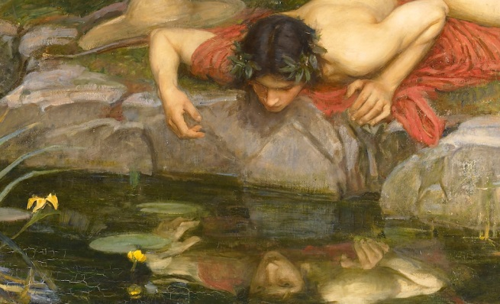
Narcissus was a very handsome boy who rejected the love of the nymph Echo, as well as the love of the boy Ameinias. Ameinias killed himself on his beloved’s door -step, and with his last breaths called on the goddess of Revenge - Nemesis - to avenge him. Nemesis led Narcissus to a reflecting pool whereupon he fell in love with his own reflection. This unrequited love caused him to lose his will to live - or he wasted away looking at himself - or he committed suicide. Many variations of the story exist, some are more gory than others. At the end of every story though, there was nothing left of Narcissus except for a small yellow flower - today’s daffodil.

VAN ENGELEN & JOHN SCHEEPERS

A great place to start shopping for Narcissi is Van Engelen Inc., a sister company to John Scheepers. Both are out of Bantam, CT. Van Engelen is appropriate for bulk purchases, John Scheepers is for smaller amounts.
The websites are:
https://www.vanengelen.com
https://www.johnscheepers.com
I contacted Van Engelen and they were kind enough to send me a couple of catalogs, and enough planting guides for everyone.

CHALLENGE ISSUED & ACCEPTED

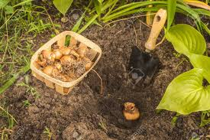
At the last meeting I was issued a challenge.

Jim Wood challenged me to a daffodil race! He said that his grandfather’s daffodils bloom very early too. He thinks they bloom earlier than my favorite recommended daffodil - Rijenveld’s Early Sensation.

If any of you are interested in joining our race, I have 20 bags of Rijenveld’s Early Sensation. 3 bulbs are in each bag. Let’s plant them this fall and compare results in the spring.

Or, if you think YOU have the earliest blooming daffodil, please keep a record of your bulb’s name and bloom time in 2019.

The race is on!

