Timely Tips

September 2019

Echinacea & Poison Ivy

Welcome back!

I hope your summer has been happy, healthy, and filled with fruits, flowers, and vegetables.

Today I have a plant I highly recommend to grow, and a plant I highly recommend to kill.

Echinacea “PowWow”

The plant to grow is Echinacea purpurea “PowWow”. It comes in two colors: deep magenta and bright white.

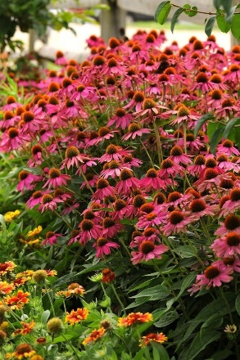
I bought the “Wild Berry” cultivar at Home Depot on July 4^{th:} 3 pots for $12. (Always shop the sales!) They haven’t stopped blooming since. AND, because I used my jab saw to cut them apart before planting, I actually got 6 plants with a final cost of $2 each. Not bad. I like them even more than traditional Echinacea because of their more manageable, compact size. I haven’t had to stake a single one.

Echinacea, commonly called coneflower, is a native pollinator plant in the sunflower family. The genus name “Echinacea” comes from the Greek word “echinos” meaning “spiny one” as in sea urchins, and is in reference to the spiny center cone. It’s those large heavy “cones”, on stems that can reach 3-4 feet tall, that cause all the drooping, falling over, making a mess problem.

Coneflower was used externally by native American tribes for wounds, burns, and insect bites. It was taken internally for pain, stomach cramps, and coughs. It is sold today in many forms (teas, tablets, powders) and is thought to stimulate the immune system.

The “PowWow” cultivar is hardy in zones 3-8, reaches a maximum height of 2-3 feet on very sturdy stems (no falling over), and blooms from June through September. It prefers full sun but will tolerate part shade. It’s a low maintenance, showy flower that attracts birds, butterflies, and bees. I think it’s a good choice for any garden.

Poison Ivy

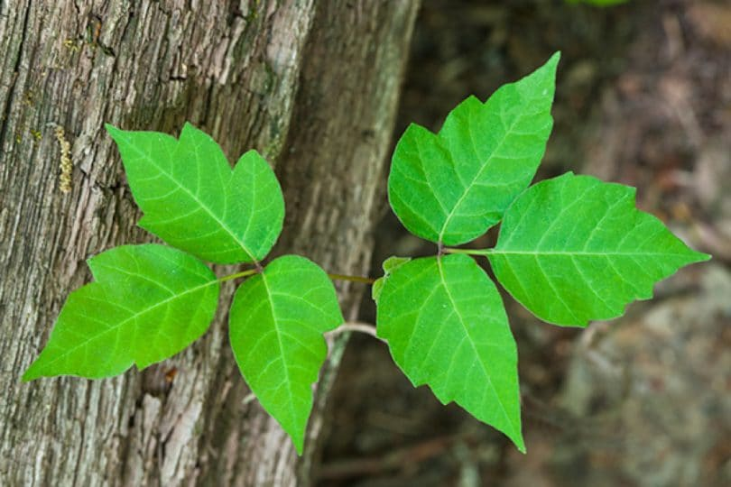
The plant to kill is poison ivy. It is the most rambunctious plant in my gardens. It’s everywhere: running along the ground, climbing trees and fences, even pretending to be a bush. It thrives on my property, and the rash thrives on me. BUT, I think I’ve finally found a way to kill it, AND to deal with the rash it produces.

Toxicodendron radicans is a member of the cashew and pistachio family (“Anacardiaceae”). It is an American native extending from Canada to South America. It grows from seed dispersal by birds & other small creatures, rhizomes, or stems with aerial rootlets.

We all know the sayings that help us identify it, and to stay away from the urushiol (“yer roosh she all”) oil it produces: “leaves of three, let it be”, “hairy vine, no friend of mine”, “berries white, run in fright”.

Lewis Ziska, a weed ecologist at the US Department of Agriculture, says poison ivy is more common, and more powerful, now than ever before. It is “particularly sensitive to CO2 levels, greatly benefiting from higher concentrations in the atmosphere. Higher carbon dioxide levels increase the rate of plant growth, creating bigger and stronger plants, and causes them to produce more unsaturated (more potent) urushiol which causes stronger reactions in humans.” 80% of us are sensitive to the oil and likely to get a rash when we contact it. We need to kill it!

I think I know how.

A few months ago, my friend Parry texted me a homemade weed killer recipe. My husband and I have been using it since with good success. None of us want to use Round Up, so this recipe is a great alternative. We futzed with the ingredients’ proportions for a while but think we have a good solution (pun intended) now.

POISON IVY KILLER:

1 gallon white vinegar
4 cups table salt
¼ cup dishwashing liquid

Dissolve the salt in the vinegar in a large pot over low heat.
Slowly stir in the dishwashing liquid.
Off heat, and allow to cool.

Pour into spray bottles and go drench that poison ivy.

This solution may NOT kill the poison ivy plant immediately. You may need to spray it a couple of times over a period of a few weeks. For very hardy, thick vines you still may have to hand pull it out of the ground. If you do have to pull it though, you should have a weakened, withered up, plant that should be much easier to handle.

Remember to treat poison ivy like a toxic waste site. You must always wear long pants, long sleeved shirts, heavy shoes, socks and gloves when working around the plant. All those items need to be thoroughly washed before using them again.

In case you come in contact with poison ivy oil, I have something for that as well: Tecnu Outdoor Skin Cleanser, or a jewelweed mash. (Since I’ve already mixed up a batch of the weed killer, I’ll save making the jewelweed mash for another time. Lots of recipes are on the web if you’re interested.)

Tecnu was kind enough to send me a load of samples and some literature about their product. They also have a new product “Tecnu EXTREME” that gently exfoliates exposed skin for greater removal of the urushiol oil.

I’ve been using Tecnu for years and it really works for me. I haven’t had a poison ivy rash in a long time. If I think I’ve rubbed against poison ivy, I immediately wash the area with Tecnu and cool/slightly lukewarm water. You do NOT want to open your pores with hot water, and allow the oil to penetrate deeper into our skin. That would make things worse.

You can buy Tecnu online, at garden centers, and at pharmacies as well.

Please feel free to help yourself to the samples, and the various propaganda.

Thank you!

